Ex.No. 2: Implementing TDMA Slot Allocation in GSM.
Objective 1: Time Slot Duration
clc;
clear;
close all;
% TDMA Parameters
FrameTime = 4.615; % Frame duration (ms)
Slots = 8; % Number of slots
SlotDuration = FrameTime / Slots;
% Time vector (8 slot centers)
t = SlotDuration/2 : SlotDuration : FrameTime - SlotDuration/2;
figure;
% TDMA Slot Structure
subplot(2,1,1);
stem(t, ones(1,Slots), 'filled');
title('TDMA Time Slot Structure');
xlabel('Time (ms)');
ylabel('Slot Level');
axis([0 FrameTime 0 1.5]);
grid on;
% Continuous Slot Allocation
subplot(2,1,2);
plot(t, ones(1,Slots), '-o', 'LineWidth', 1.5);
title('Continuous View of Slot Allocation');
xlabel('Time (ms)');
ylabel('Slot Presence');
axis([0 FrameTime 0 1.5]);
grid on;
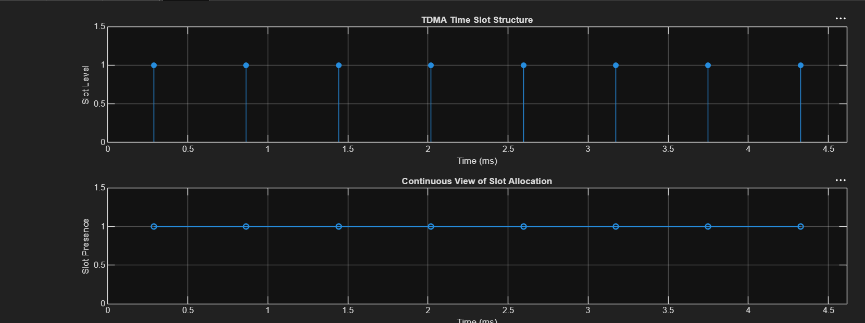
Objective 2: Frame Utilization (%)
clc;
clear;
close all;
% GSM Frame Parameters
TotalSlots = 8;
AllocatedSlots = 6;
FreeSlots = TotalSlots - AllocatedSlots;
% Frame Utilization
Utilization = (AllocatedSlots / TotalSlots) * 100;
disp('Frame Utilization (%)');
disp(Utilization);
figure;
% Graph 1: Line Plot
subplot(2,1,1);
plot([1 2], [AllocatedSlots FreeSlots], '-o', 'LineWidth', 2, 'MarkerSize', 8);
title('GSM Frame Utilization (Allocated vs Free)');
xlabel('Slot Type');
ylabel('Number of Slots');
xticks([1 2]);
xticklabels({'Allocated','Free'});
grid on;
% Graph 2: Pie Chart
subplot(2,1,2);
pie([AllocatedSlots FreeSlots]);
title('Slot Distribution in GSM Frame');
legend('Allocated','Free','Location','best');
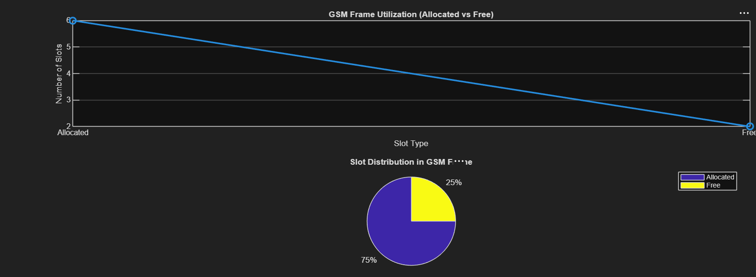
Objective 3: Number of Allocated Time Slots
clc;
clear;
close all;
Users = 1:8;
Alloc = [1 1 1 1 1 0 0 0];
Blocked = 1 - Alloc;
disp('User Allocation');
disp([Users' Alloc']);
figure;
subplot(2,1,1);
stem(Users, Alloc, 'filled');
title('TDMA Slot Allocation');
xlabel('User');
ylabel('Allocated');
grid on;
subplot(2,1,2);
plot(Users, Alloc, '-o', Users, Blocked, '-s', 'LineWidth', 1.5);
title('Allocated vs Blocked');
xlabel('User');
ylabel('Status');
legend('Allocated','Blocked');
grid on;
